1+1

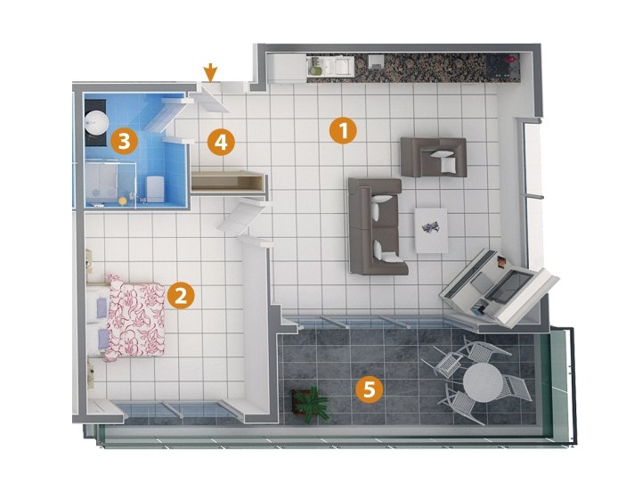

1- Living Room 36 m²

2- Bedroom 15 m²

3- Bathroom 5 m²

4- Entry 3 m²

5- Balcony 17,5m²