**2+1 GARDEN DUPLEX**

**Ground floor**

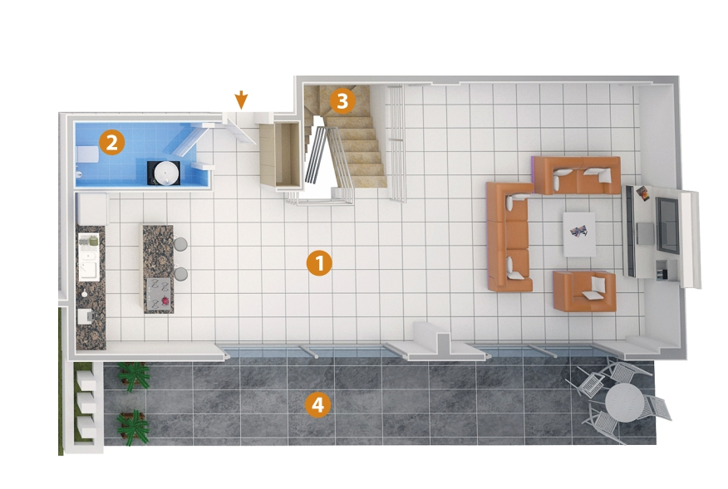

1- Living Room 54 m²

2- Bathroom 3,5 m²

3- Stairs 5 m²

4- Balcony 33 m²

**Upper floor**

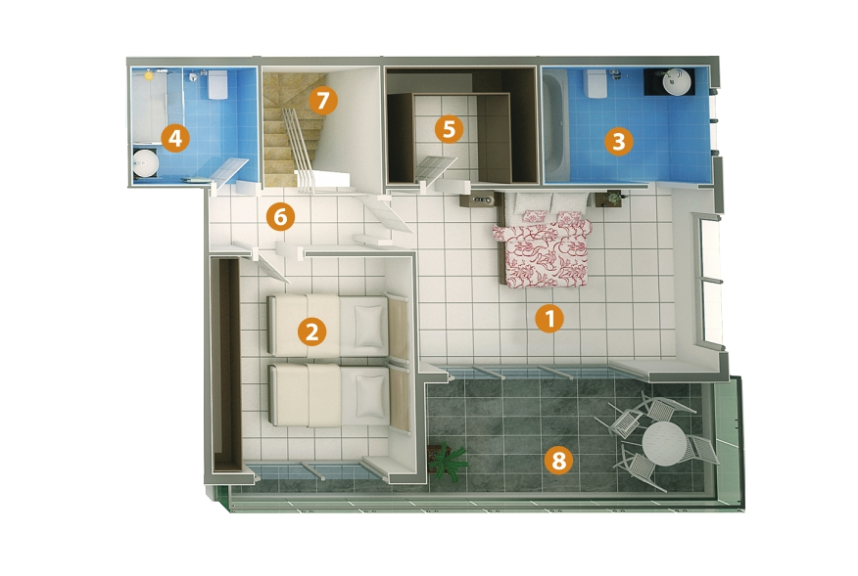

1-Bedroom 20 m²

2-Bedroom 14 m²

3-Bathroom 7 m²

4-Bathroom 5 m²

5-Dressing Room 7 m²

6-Hall 4 m²

7-Stairs 5 m²

8-Balcony 17,5 m²