**2+1 NORMAL FLOOR**

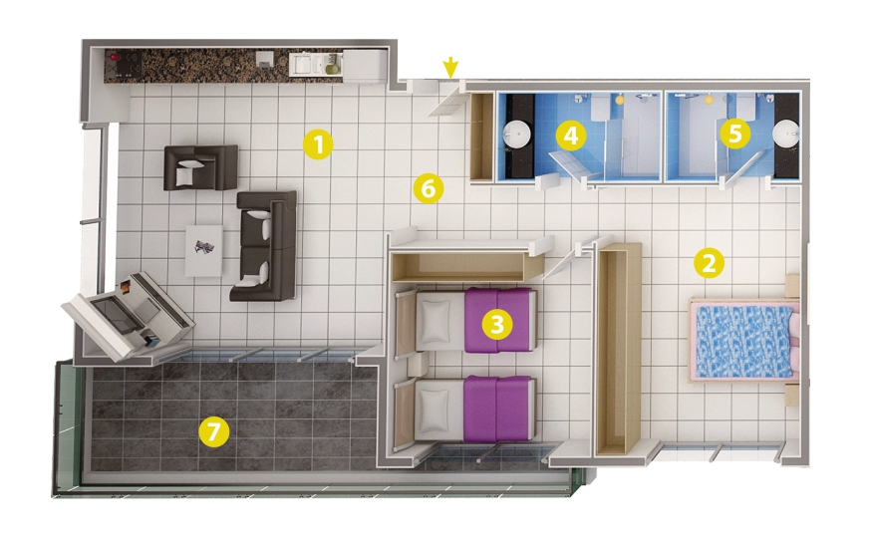

1- Living Room 36m²

2- Bedroom 17 m²

3- Bedroom 13 m²

4- Bathroom 4,5 m²

5- Bathroom 4,5 m²

6- Entry 7 m²

7- Balcony 17,m²