3+1 Garden Dublex

Ground Floor

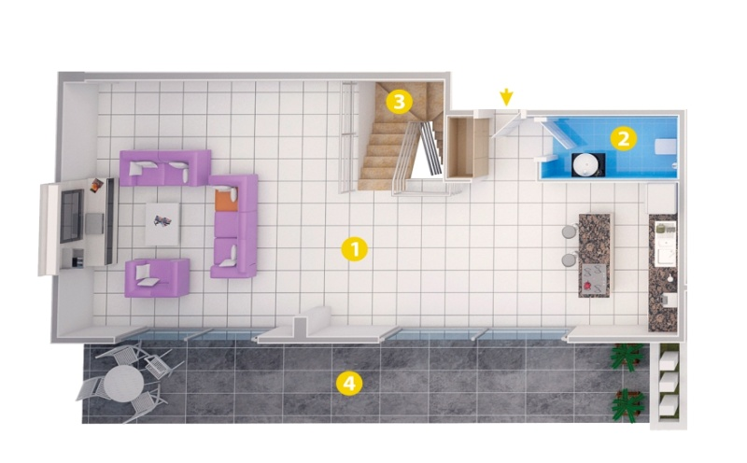 1-Living Room 54

2-Bathroom 3,5

3-Stairs 5

4-Balcony 33

Upper Floor

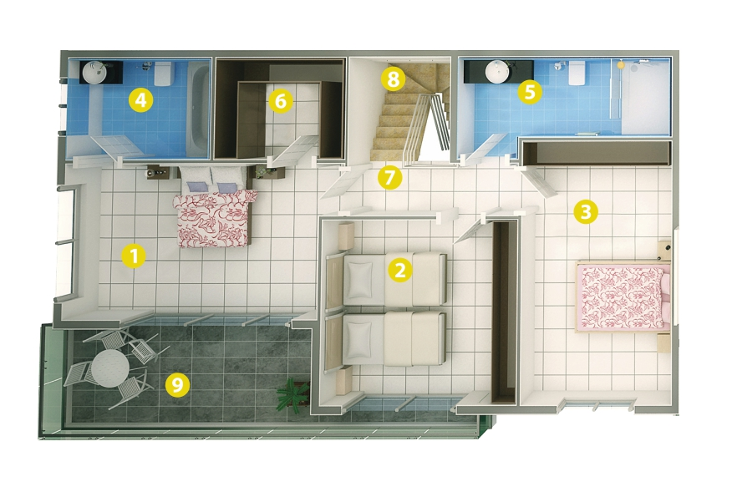 1-Bedroom 20

2-Bedroom 15,5

3-Bedroom 17,5

4-Bathroom 7

5-Bathroom 8,5

6-Dressıng Room 7

7-Hall 4 8-Stairs 5