**3+1 PENTHOUSE**

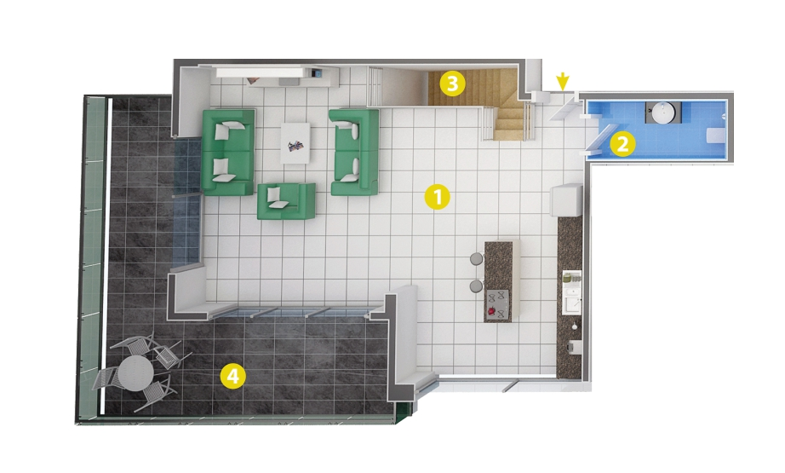

1- Living Room 68 m²

2- Bathroom 4 m²

3- Stairs 5 m²

4- Balcony 32 m²

**PENTHOUSE ROOF FLOOR**

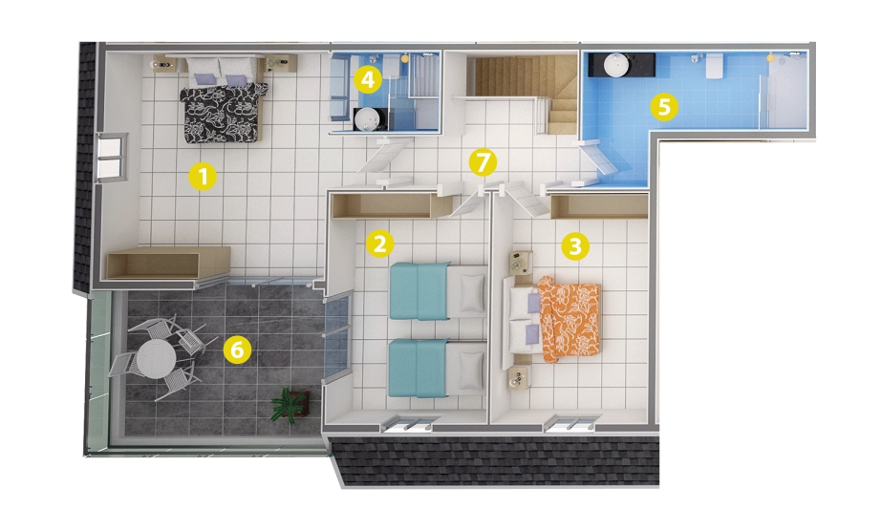

1-Bedroom 25 m²

2-Bedroom 28 m²

3-Bedroom 23,5 m²

4-Bathroom 6 m²

5-Bathroom 10,5 m²

6-Balcony 18,5 m²

7-Entry 7,5 m²