**1+0 STUDİO**

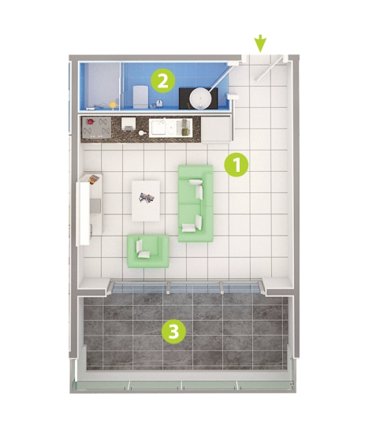

1- Livıng Room 27 m²

2- Bathroom 4 m²

3- Balcony 10,5 m²